Project Initialization and Planning Phase

Date | 28 September 2026
Team ID | SWTID-2026-1526
Project Name | AI StudyBuddy
Maximum Marks | 3 Marks

Define Problem Statements (Customer Problem Statement Template):



Create a problem statement to understand your customer's point of view. The Customer Problem Statement template helps you focus on what matters to create experiences people will love. A well-articulated customer problem statement allows you and your team to find the ideal solution for your customers' challenges. Throughout the process, you’ll also be able to empathize with your customers, which helps you better understand how they perceive your product or service.

Example:
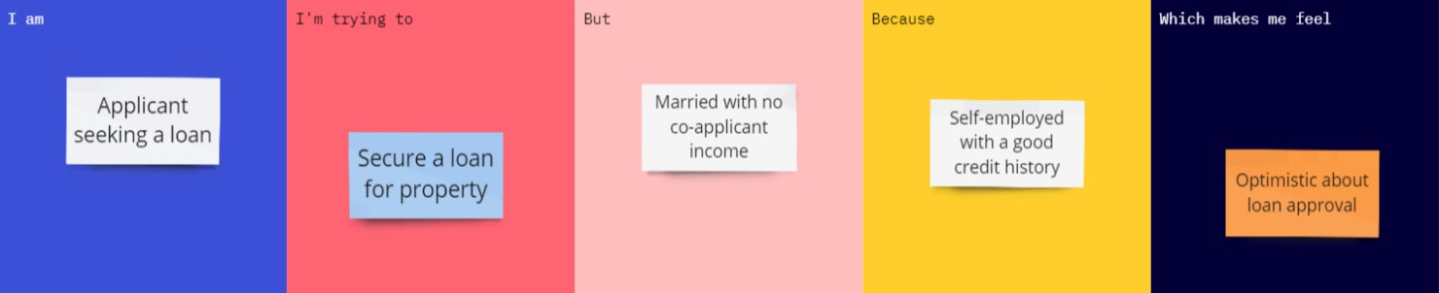

Problem  Statement  (PS) | I am (Customer) | I’m trying  to | But | Because | Which makes me feel
PS-1 | A second-year engineering student preparing for semester examinations. | Quickly cover, organize, and revise large amounts of study material from various sources. | Manual summarization, note-taking, and quiz-making take away valuable study time and effort. | Learning resources are scattered across multiple platforms with no personalized study schedule or automated AI tools. | Overwhelmed, unproductive, and stressed about exam preparation and time management.

